1.57: a) The area of one acre is 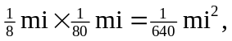so there are 640 acres to a square mile.

b) 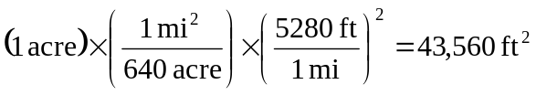

(all of the above conversions are exact).

c) (1 acre-foot)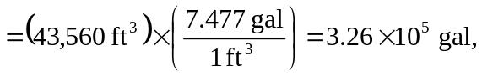
which is rounded to three significant figures.

